Digital Campus Business Requirements Document

Votary Softech Solutions Pvt. Ltd.

Plot No: 76, Lumbini layout,   
Near Euro school,   
Gachibowli-I (V), Hyderabad,  
Telangana - 500032,   
India.

**Revision History**

|  |  |  |  |  |  |
| --- | --- | --- | --- | --- | --- |
| Version (x.y) | Date of Revision | Description of Change | Reason for Change | Affected Sections | Approved By |
|  |  |  |  |  |  |
|  |  |  |  |  |  |
|  |  |  |  |  |  |

**Approval History**

|  |  |  |  |
| --- | --- | --- | --- |
| Version (x.y) | Prepared By | Reviewed By/Date | Approved By/Date |
|  |  |  |  |
|  |  |  |  |
|  |  |  |  |

**Contents**

1 Define 4

1.1 Objective 4

1.2 Deliverables 4

1.3 Prerequisites 4

1.4 Assumptions 4

1.5 Limitations 4

1.6 Business Risks 4

1.7 Glossary 4

2 Specify 4

2.1 Scope 4

2.2 Schedule and Milestones 4

2.3 Resources 4

2.4 Cost 4

2.5 Market Analysis 5

2.5.1 Competitor Information 5

2.5.2 Substitutes in Market for Product 5

2.5.3 Targeted Domains 5

3 Architecture 5

3.1 Block Diagram 5

3.2 Internal Interfaces 5

3.3 External Interfaces 5

4 Design 5

4.1 Flowcharts 5

4.2 Development Environment 5

4.3 IP Identified 5

5 Implement 5

5.1 System Requirements 5

5.1.1 <Module based> Functional Requirements 6

5.2 Revenue Realization Plan 6

5.3 User Acceptance Criteria 6

5.4 Quality Plan 6

6 Validate 6

7 Deploy 6

8 Maintain 6

# Define

Digital Campus has capabilities to detect employee ble/BT tag location through standalone gateways, In-time out-time, Dwell times of employee

## Objective

Purpose of this project is to locate, track employee through ble/BT tag and to get hands on experience to Engineer’s from LC on a project life cycle

## Deliverables

* Digital Campus Gateway
* SQL Database
* User Application (Desktop/Mobile)

## Prerequisites

NA

## Assumptions

Every Employee will carry BT/BLE tag

## Limitations

Gateway can detect Max 255 BT/BLE devices

## Business Risks

NA

## Glossary

|  |  |
| --- | --- |
| BT | Bluetooth Classic |
| BLE | Bluetooth Low Energy |

# Specify

Digital Campus has the capabilities to locate and get details like in/out time of employee

It has three modules in it:

1. Gateway Module – Provides the capability to scan continuously for nearby BLE/BT devices and publishes data to storage module
2. Storage Module – Stores the received BLE/BT data in a specific format and provides access to application to query the required data

3. Application Module – It provides as interface where end user can query required data i.e locate, in/out time

## Scope

Digital Campus will provide infrastructure where one can get employee location, density and dwell times etc. Through various APIs categorized below:

Scan and Discover BT/BLE Devices

Store To Database

User Application

## Schedule and Milestones

NA

## Resources

NA

## Cost

NA

## Market Analysis

### Competitor Information

NA

### Substitutes in Market for Product

NA

### Targeted Domains

NA

# Architecture

## Block Diagram

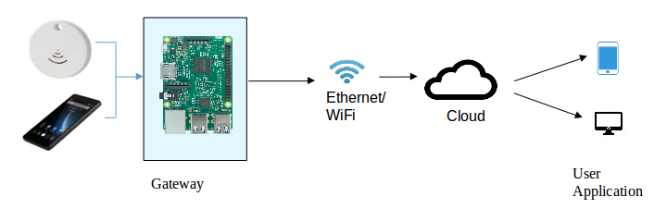

## Internal Interfaces

None as of now

## External Interfaces

SQL Database

Application

# Design

## Flowcharts

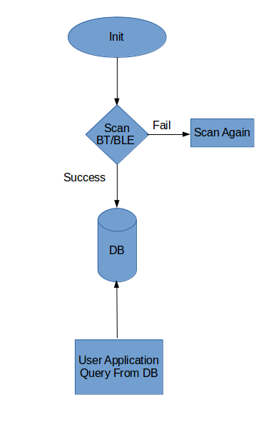

## Development Environment

GCC (Compiler)

QT Creator

Vi

SQL

## IP Identified

As of Now NO

# Implement

## System Requirements

Digital Campus provides below features through various APIs categorized below:

* Scan and Discover BT/BLE Devices
* Store To Database
* User Application

### <Module based> Functional Requirements

|  |  |  |
| --- | --- | --- |
| SL # | Requirements | Description |
| 1 | REQ - DC001 | User can locate last known/Current location of employee |
| 2 | REQ – DC002 | User can query In/Out time of employee |
| 3 | REQ – DC003 | User can get Dwell Time of Employee |
| 4 | REQ – DC004 | User can get number of employee’s by gateway |

## Revenue Realization Plan

NA

## User Acceptance Criteria

* Gateway Should able to Scan Continuously for BT/BLE Devices and push to database
* User Application Should able to Query/Filter Details from database as required I.e Employee location, Dwell Times

## Quality Plan

<Quality Standards that will be maintained by the Project at a High level. CMMI 3?>

# Validate

<References to Review Log and Checklist for BRD deliverable>

# Deploy

<Share BRD for signoff, references to emails sent and signoffs received and baseline the BRD>

# Maintain

<Versions of BRD changes references>